Relay

Main Feature

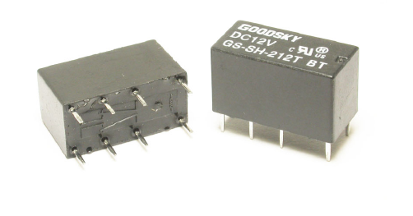
1. 92/8 gold silver alloy on silver palladium contact type is suitable for low level switching application.
2. Small size and light weight can provide
high density P.C. Board mounting.
3. 2.54gmm Terminal Pitch.
4. Low Coil Power Consumption of
GS-T Type and high Coil Power
Consumption of GS-D type are available to meet user’s selection.
5. Employment of suitable plastic materials to be applied to high temperature and various chemical solution.
6. Plastic epoxy resin sealed type for washing procedure.

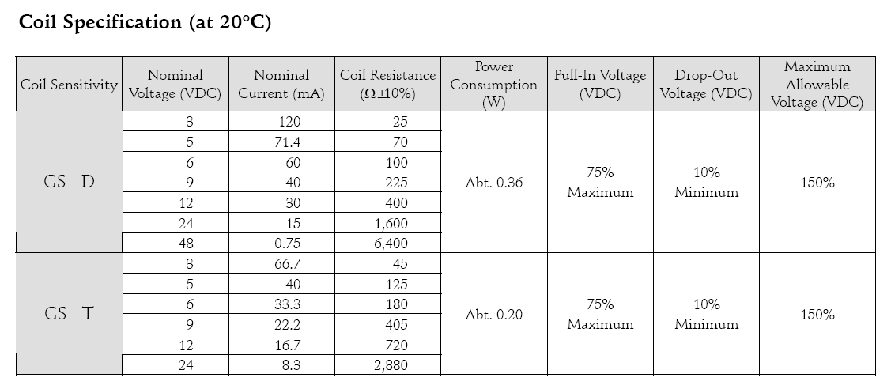

Application

Telecommunication, domestic appliances, office machine, audio equipment, Remote Control, etc.

